

Watershed UGA

Data Management Portal

User Guide

**Users**

There are three levels of access for users of the Data Management Portal. The users are as follows:

1. *Public Users* – Login Access: **No**
   1. Users with this level of access can view and export water quality and monitoring point data.
2. *Data Users* – Login Access: **Yes**
   1. Users with this level of access can update, add, view and export data.
3. *Administrators* – Login Access: **Yes**
   1. Users with this level of access can update, add, view and export data, as well as manage other user accounts.

**Data Management Portal Home Page**

Visitors to the Watershed UGA Data Management Portal will begin their journey on the Home Page (see below). From the home page, users will be able to navigate to:

1. Pages Displaying Data
2. The Watershed UGA Main Site
3. The Watershed UGA Maps Page
4. A Login Page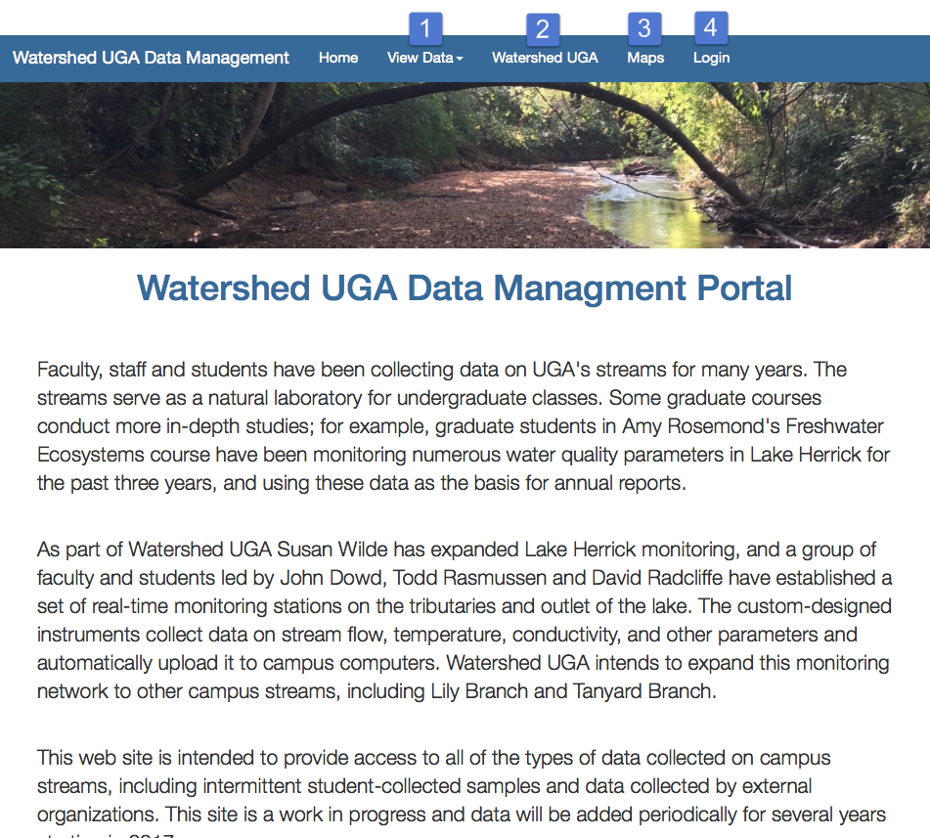

**View Data (Public User)**

From the Home Page, public users can choose to view collected water quality data or monitoring point data. Once the public user has navigated to a data page, he/she will have the option to export data to a .csv file via the “**Export**” button at the top of the page..

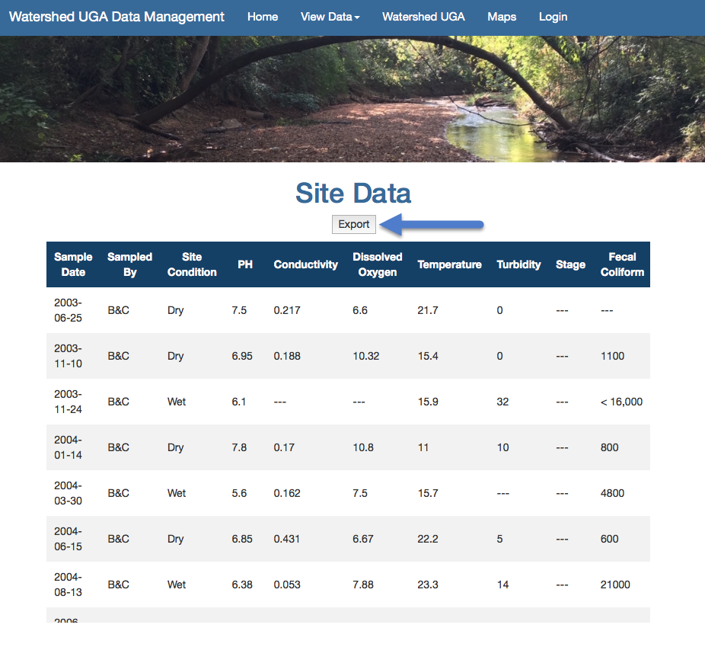

**Export Data (Public User)**

When choosing to export water quality data, public users have the option to export data from **A)** selected sites and site points or **B)** all the data at once.

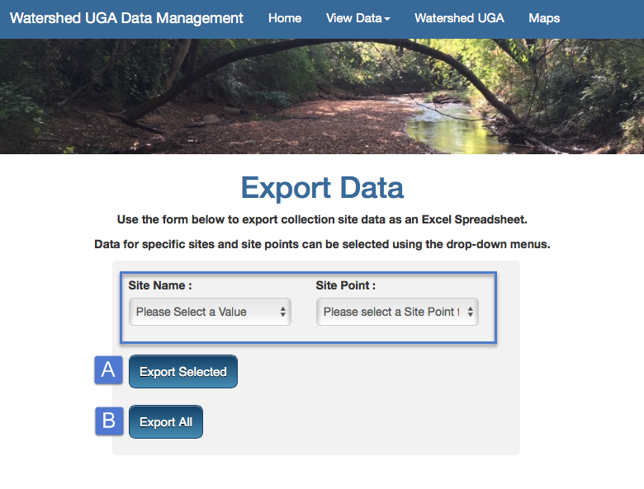

To export site specific data, users can choose specific Site Names and corresponding Site Points via the dropdown menus. Then they can click “**Export Selected**.”

*\*\*\*NOTE: The export functionality is not currently supported in Google Chrome.\*\*\**

**Logging In**

As noted earlier, Data Users and Administrators can log in to the Data Management Portal to access more advanced functionality. To login, users can click the “**Login**” link located on the right side of the navigation bar.

The user will be taken to a login screen where they will be prompted to enter an **A)** email address and **B)** password to complete the login.

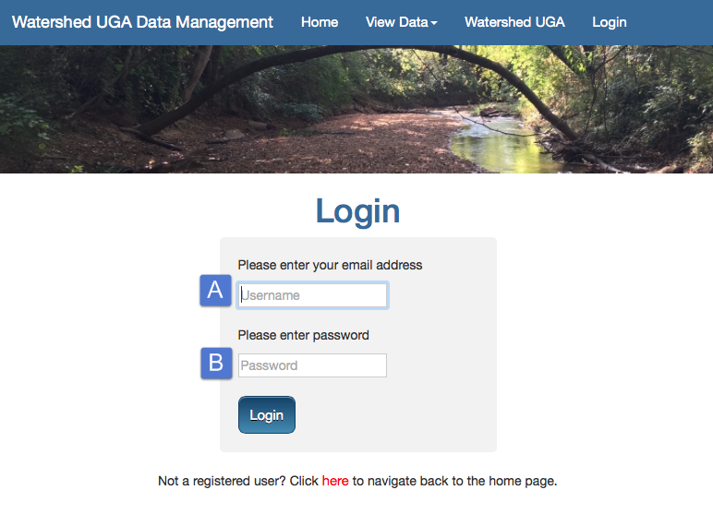

Please note that a user will have **three attempts** to login and will be given a warning following each failed attempt.

Upon login, Data Users will be taken to the Data Management Portal Dashboard and Administrators will be taken to the Administration Dashboard.

**Administration Dashboard (Administrator)**

The Administration Dashboard is the landing page for logged in Administrators. From the Dashboard, administrators can access the following pages:

1. Enroll Users – to enroll both Data Users and other Administrators
2. User Admin – to update profiles and delete users
3. Home – navigates the user back to the Data Management Portal home
4. Sign Out – logs the user out
5. Update Data – to update, delete, or export current water quality data
6. Update Site – to update, delete or export current monitoring site information
7. Add Data – to new add water quality data into the database
8. Add Site – to add a new monitoring site into the database

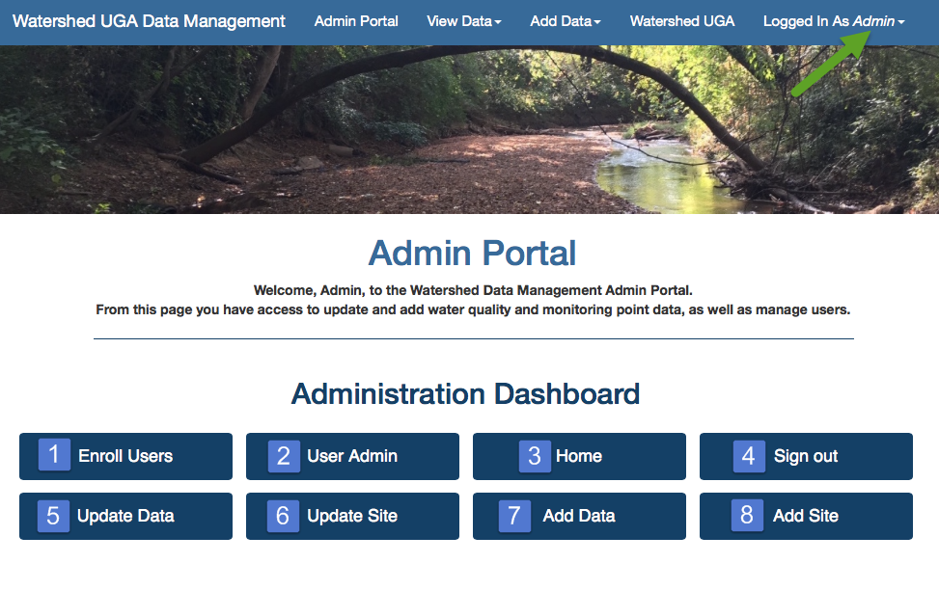

*Note that the site will display the name of the user that is currently logged in at the far right side of the navigation bar.*

**Enroll User (Administrator)**